**Packet Tracer Lab1**

|  |  |  |  |  |
| --- | --- | --- | --- | --- |
| Network Segment | Device Name | Interface | IP Address | Subnet mask |
| LAN 1 | PC0 | Fa0 | 192.168.100.2 | 255.255.255.0 |
| PC1 | Fa0 | 192.168.100.3 | 255.255.255.0 |
| Switch0 | Fa0/1 to Fa0 (PC0) | NA | NA |
| Fa0/2 to Fa0 (PC1) |
| Fa0/3 to Gig 0/0/0 |
| Router0 | Gig0/0/0 | 192.168.100.1 | 255.255.255.0 |
| Gig0/0/1 | 192.168.1.1 | 255.255.255.0 |
| LAN 2 | PC2 | Fa0 | 192.168.10.2 | 255.255.255.0 |
| PC3 | Fa0 | 192.168.10.3 | 255.255.255.0 |
| Switch2 | Fa0/1 to Fa0 (PC2) | NA | NA |
| Fa0/2 to Fa0 (PC3) |
| Fa0/3 to Gig 0/0/0 |
| Router1 | Gig0/0/0 | 192.168.10.1 | 255.255.255.0 |
| Gig0/0/1 | 192.168.1.2 | 255.255.255.0 |

**Network Topology**

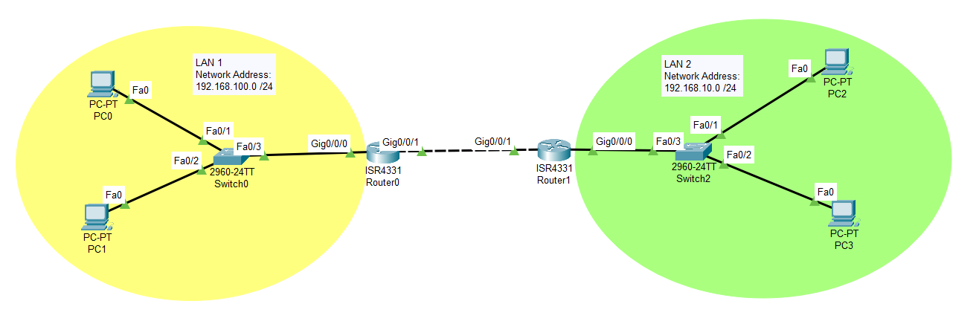

**LAN 1 Configuration:**

**PC0**

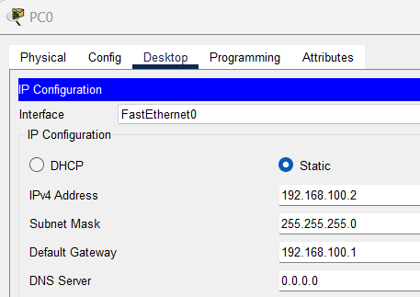

**PC1**

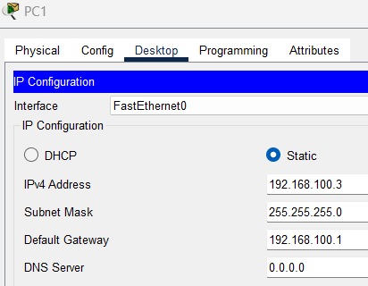

**R0**

**LAN 2 Configuration:**

**PC2**

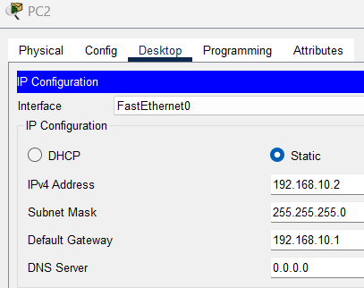

**PC3**

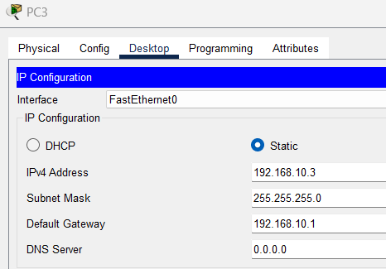

**R1**

